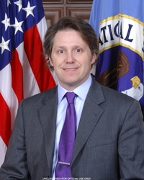
Neal Ziring
[current as of Oct 2016]

Mr. Neal Ziring is the Technical Director for the National Security Agency’s Capabilities Directorate, serving as a technical advisor to the Capabilities Director, Deputy Director, and other senior leadership. Mr. Ziring is responsible for setting the technical direction across many parts of the capabilities mission space, including in cyber-security. Mr. Ziring tracks technical activities, promotes technical health of the staff, and acts as liaison to various industry, intelligence, academic, and government partners. Prior to the formation of the Capabilities Directorate, Mr. Ziring served 5 years as Technical Director of the Information Assurance Directorate.
His personal expertise areas include security automation, IPv6, cloud computing, cross-domain information exchange, and data access control, and cyber defense.
Prior to coming to NSA in 1988, Neal worked at AT&T Bell Labs. He has BS degrees in Computer Science and Electrical Engineering, and an MS degree in Computer Science, all from Washington University in St. Louis.

